Curriculum Vitae (C.V.)
- Personal data:
Name (Arabic) | فاتن محمد عبد التواب عواد خليفة
Name (English) | Faten Mohamed Abdeltawab Awad khalifa
Department | Rheumatology Rehabilitation and physical Medicine
College | Medicine
Academic degree | Lecturer
Office Address | Benha faculty of Medicine
Mobile 1 | 01122254083
Home phone | 0132453191
Work phone
Fax
Email (university) | faten.khalifa@fmed.bu.edu.eg
Email (alternative) | Faten.abdeltawab@gmail.com
Web site (if any)
Recent Photo (passport format) | 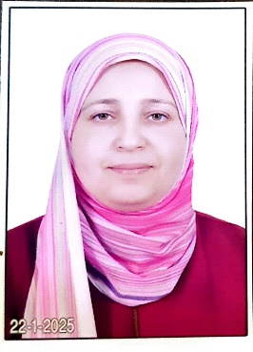
- Education: MD degree
2.A. Degree obtained;
Institution | Degree obtained | Year
 | MD | 2023
 | Master | 2018
 | Baclor of Medicine | 2013

2.B. Specialty;
General specialty. | Rheumatology Rehabilitation physical Medicine
Specific specialty. | Rheumatology Rehabilitation physical Medicine

2.C. Language skills (Excellent, Very Good, Good or Basic);
Language | Reading | Speaking | Writing
Arabic. | Yes | Yes | Yes
English. | Yes | Yes | Yes
French.
Other (specify).

- Positions:
Tittle | Year | University/Institution
Lecrure | 2023 | Benha /faculty of Medicine
Assistan lecture | 2018 | Benha university faculty of Medicine

- Cooperation with local and international entities having website:
( جامعة – مؤسسة - وزارة – مركز بحثي – عضو هيئة تدريس – باحث - شركة – مصنع – الخ)
Name of local and international entity | Website
- Membership of professional bodies (List):

- Membership of institute (List):

- Distinction and Awards (List):

- Academic:
Courses at under graduate level;
1. Course name: | Clinical rounds;
2. Course name: | Lectures;
Courses at post graduate level;
1. Course name: Nerve conduction study and EMG courses | Clinical rounds;
2. Course name: | Lectures;
- Areas of research:

- PhD/M.Sc Supervision:
Title | PhD/M.Sc | Year completed / in progress
Prevalence of comrbidities in patients of rheumatoid arthritis | Master degree | 2018
Medication adherence in patients of rheumatoid arthritis and juvenile idiopathic arthritis comparative study | MD degree | 2023

- Grants for Projects:
Funding organization | Project title | Role | Year
- Committees:

- List of Publications:

14. Attended Workshops, Symposiums, and Conferences: "List name and year";

Name of Workshops, Symposiums, and Conferences | Year
13.1. El Agouza rehabilitation conference 2025  Botulinum injection work shop 2025  BLS workshop 2025 | 2005

- Books published:

16. Positions:
 | Date | Organization | Country | Position
1
2
3

17. Activities in faculty/university/community service:
Name of Activity service | Year
- Teaching (Rounds and lectures). | Yes
- Clinical meeting.
- Making conferences. | Rheumatology Rehabilitation physical Medicine conference of benh university 2025
- Medical Convoys.
- Workshops. | Basic NCS. And EMG work shop trainer at benha university
18. Consulting Experience (if any):

19. Additional information you would like to put on the website:

